# INTRODUCTION

* 1. *Overview*
* Aims relate to the overall intent, strategic direction and purpose of your event i.e. the primary motivations.
* Objectives are essentially aims broken down into specific targets, to facilitate event delivery and evaluation.
  1. ***Purpose***
* Event management is the process of creating and maintaining an event.
* This process spans from the very beginning of planning all the way to post-event strategizing.
* . At the start, an event manager makes planning decisions, such as the time, location, and theme of their event.

1. **Problem Definition & Design Thinking**
   1. *Empathy Map*

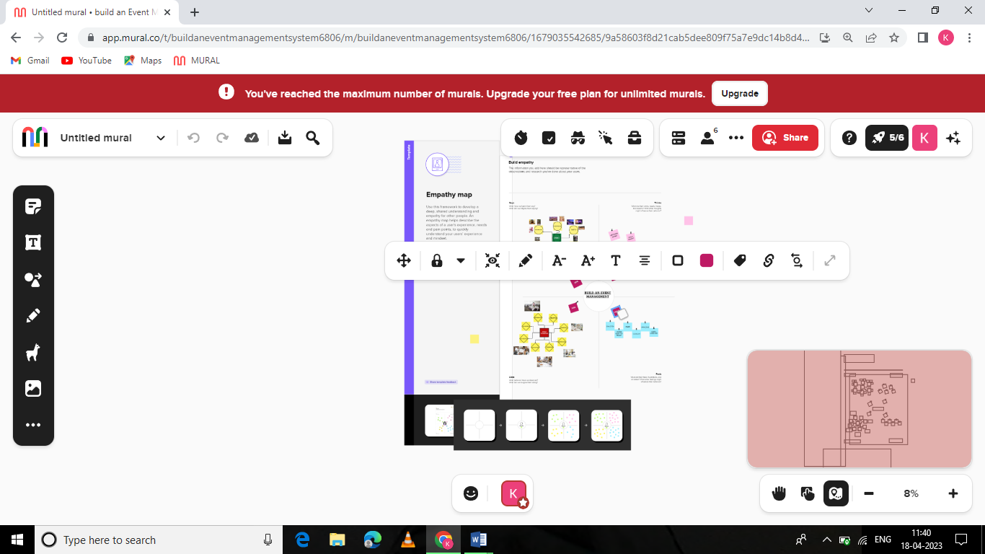

* 1. ***Ideation & Brainstorming Map***

**Data Model** 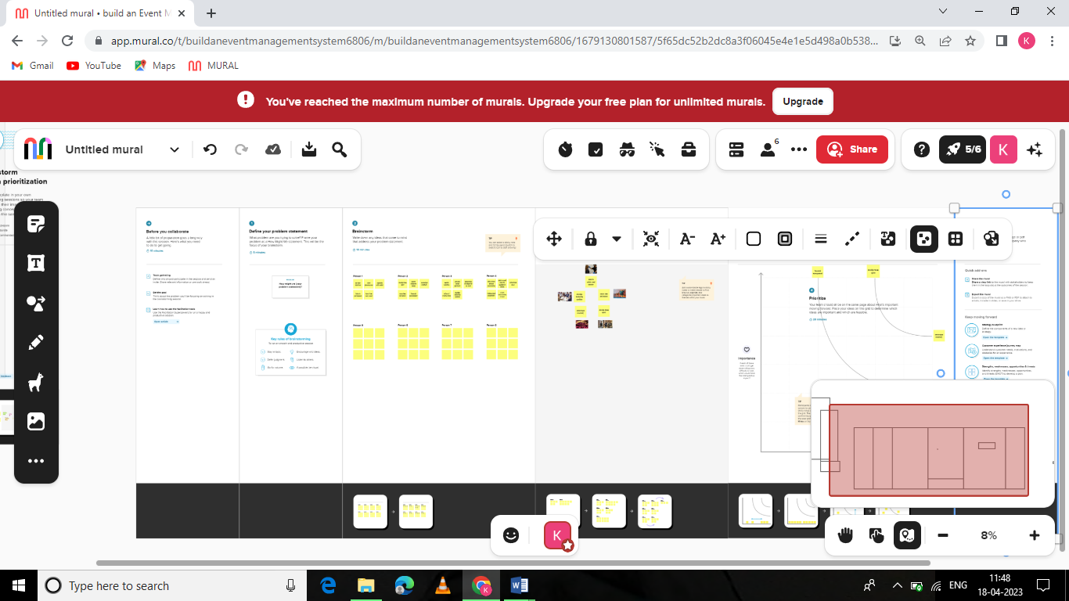

# RESULT

* 1. *:* ***Data Model***

|  |  |
| --- | --- |
| Field label | Data type |
| Enter id | Auto number |
| Phone | Phone |

|  |  |
| --- | --- |
| **Object name** | **Fields in the Object** |
| Obj1  ATTENDEES |  |
| obj2  SPEAKER |  |

# Activity & Screenshot

|  |  |
| --- | --- |
| Field label | Data type |
| Enter Bio | Text Area |
| Email | e-mail |

# Milestone:4

# Activity:2

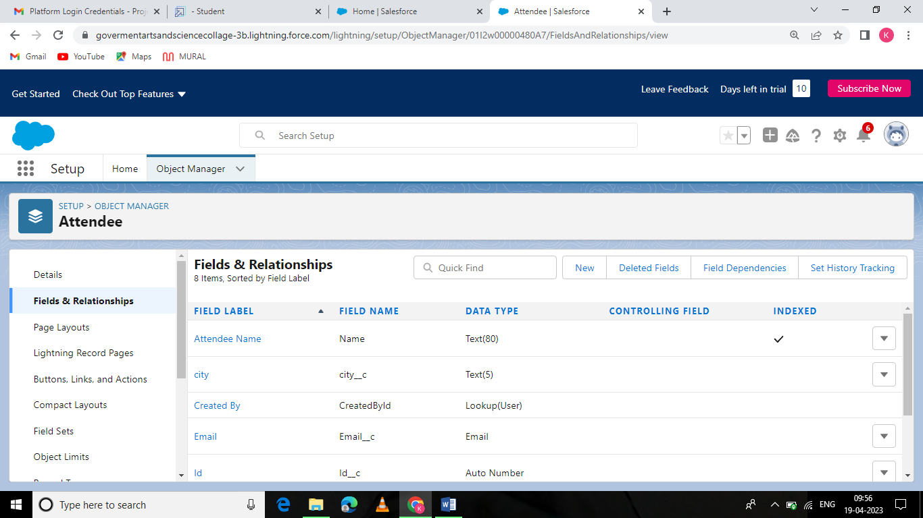

# Mileston:5

# Activity:1

# 

# Mileston:4

# Activity:5

# 

# Milestone:3

# Activity:1

# 

# Milestone :3

# Activity:1

# 

# Milestone:7

# Activity:1

# 

# Milestone:8

# Activity:1

# 

# Trailhead Profile Public URL

**Team Lead**

**A.KAVINMATHI https://trailblazer.me/id/kavia33**

# Team Member 1

**S.GOMATHI: https://trailblazer.me/id/gseethu**

# Team Member 2

# 

# P.MADHUMITHA: https://trailblazer.me/id/pmadhumitha

# Team Member 3

# K.MAHALAKSHMI:

# https://trailblazer.me/id/mahak56

1. **ADVANTAGES**

***ADVANTAGES:***

1. An Event Planner Will Help You Bring Your Vision To Life.

2. Organization And Details.

3. Budgeting For Your Wedding. ….

4. Timeliness And Flexibility…

5. Your Event Planner Will Be There For You

# APPLICATIONS

1. Promote your Event .Sounds strange , right?...
2. Sell Event Tickets. ….
3. Targeted Digital Marketing. …
4. Drive Pre-event Engagement. …
5. Push Notification. …
6. Enables Effective Communication. ..
7. Establish An Attendee Network.
8. Event Apps Help With Branding

# CONCLUSION

* Event Management is user friendly and cost effective system/
* It is customized with activities related to event management life style

# FUTURE SCOPE

1. It involves management , creation and development of events such as corporate conferences ,wedding ,festivities formal parties etc..
2. It involves a lot of research about the brand, target audience and the concept of the event before planning the actual event.